**Project Development Phase**

**Sprint 2**

|  |  |
| --- | --- |
| Date | 03 November 2022 |
| Team ID | PNT2022TMID41225 |
| Project Name | Global Sales Data Analytics |

**Sprint 2 tasks:**

* Connecting data from IBM cloud to IBM cognos
* Connecting schema and table
* Data visualization
* Prepare the dataset
  + Data Joins
  + Data calculations
  + Data navigation
  + Data formatting
* Creating Dashboard

**Connecting data from IBM cloud to IBM cognos:**

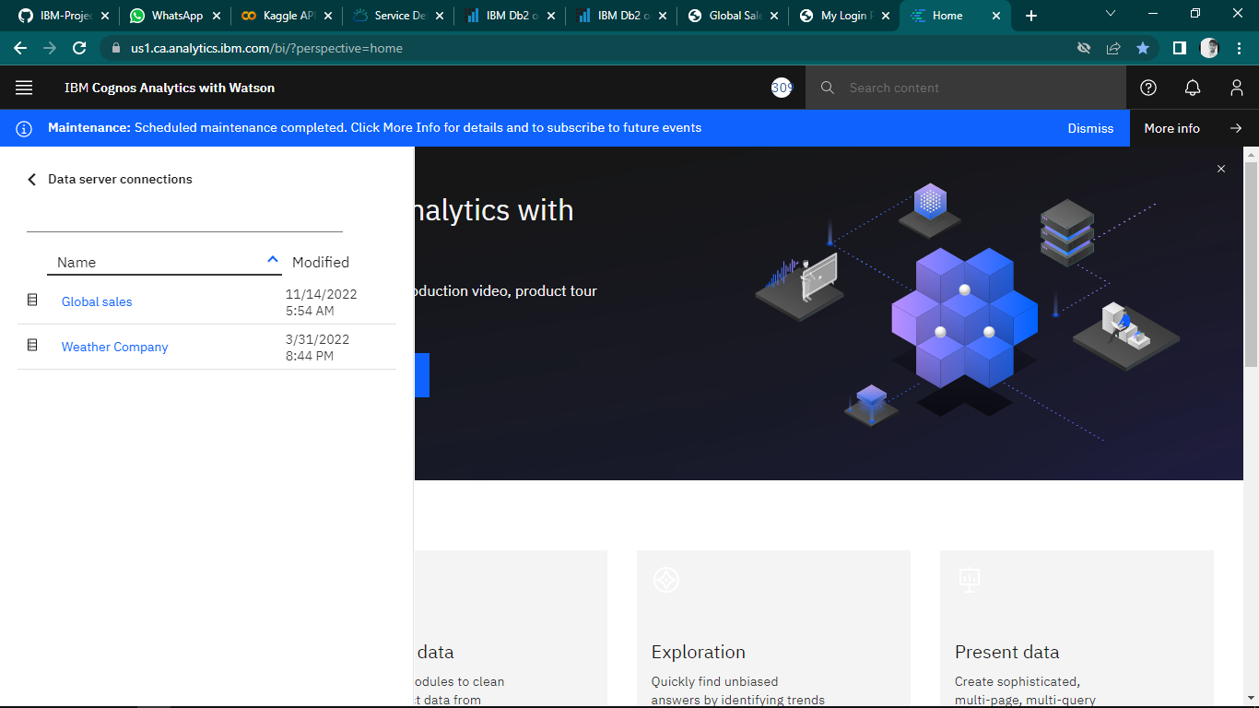

**Connecting schema and table:**

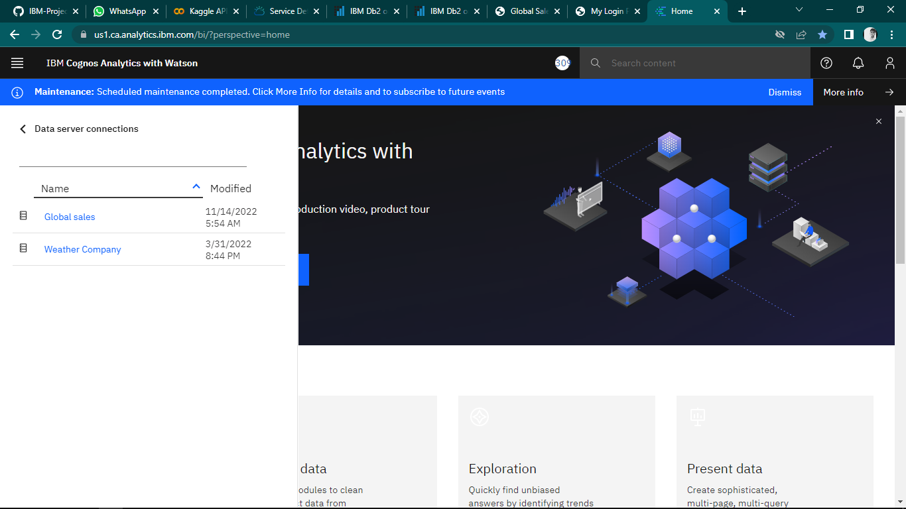

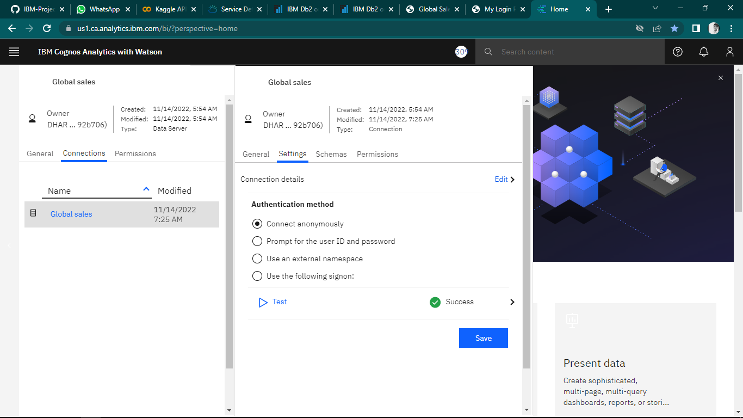

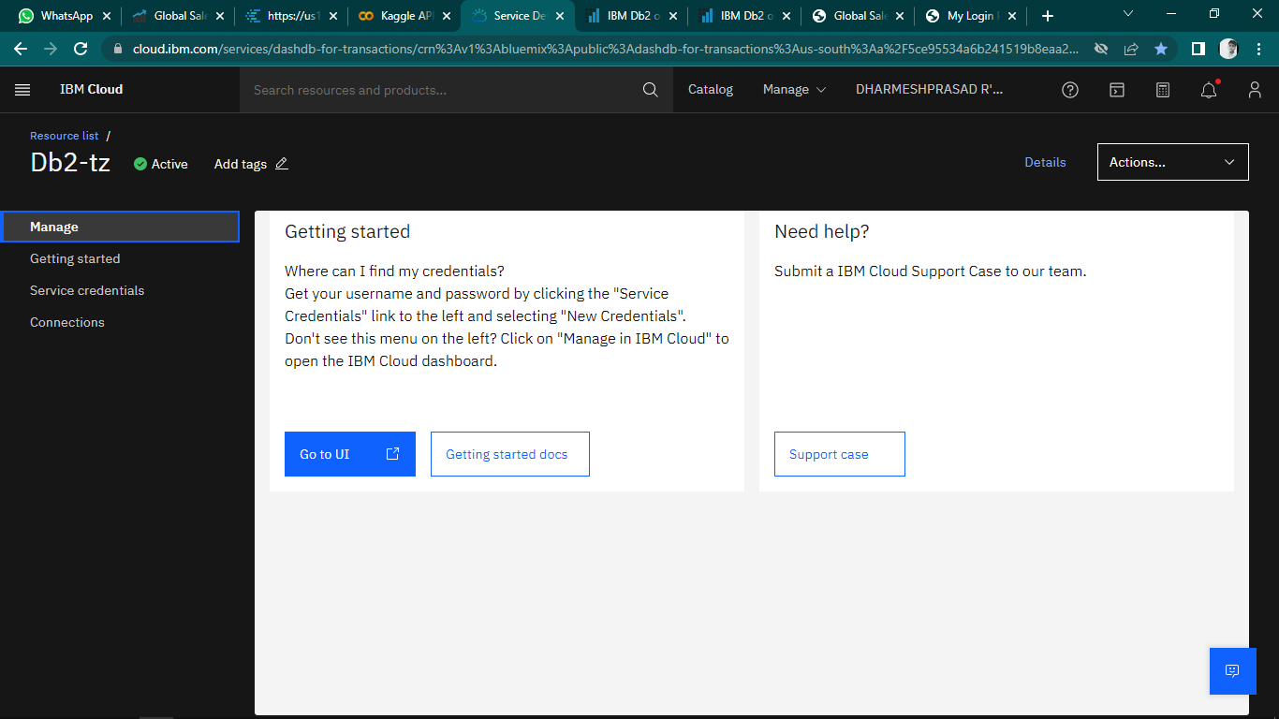

**Data visualization:**

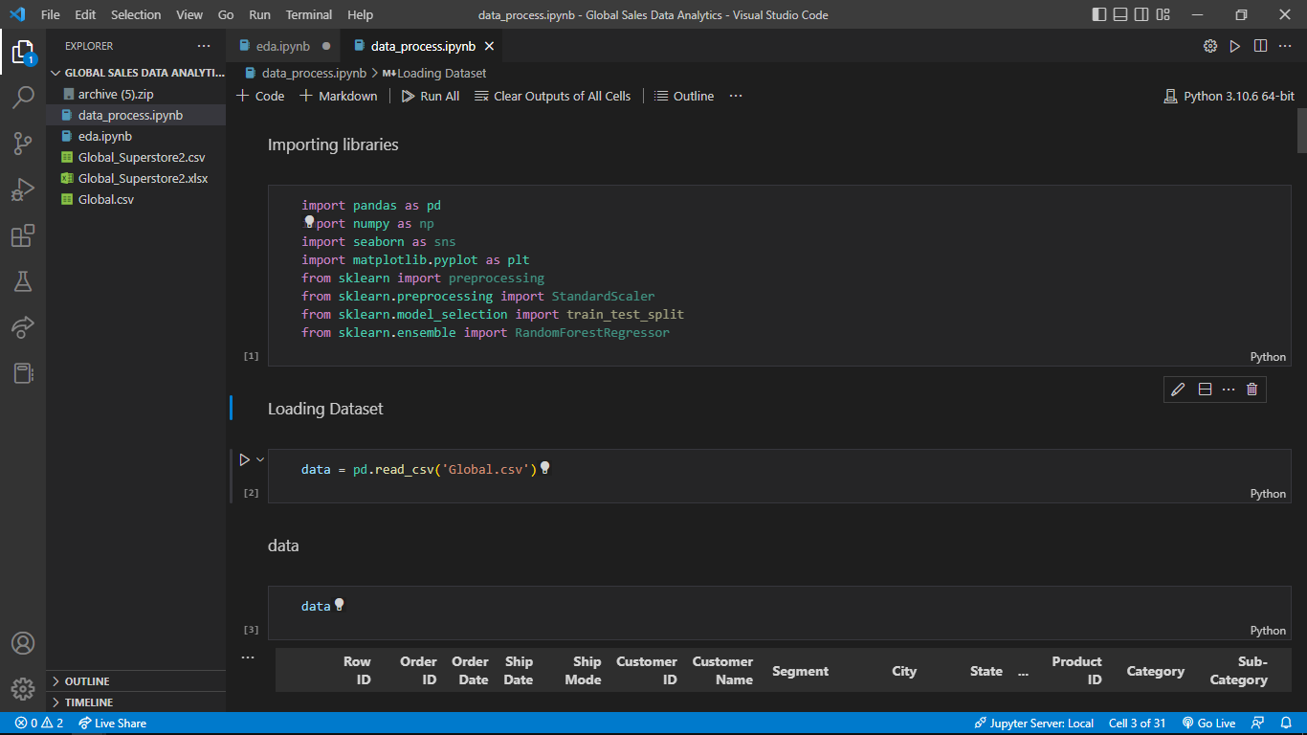

**Prepare the dataset:**

Understanding rows and columns of the data.

**a. Data Joins:**

Analysing that the dataset module requires joins.

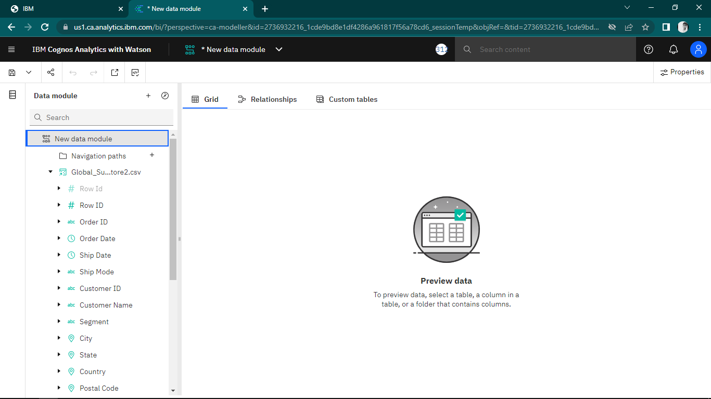

**b. Data Calculations:**

Creating calculations for extracting year, month and day from order date column.

1. **Year calculation**

Creating calculations for extracting year from order date column.

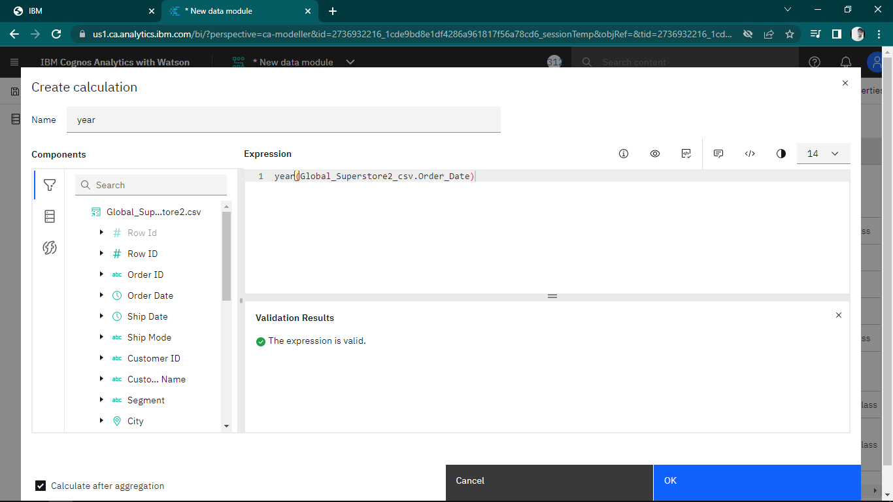

1. **Month calculation**

Creating calculations for extracting month from order date column.

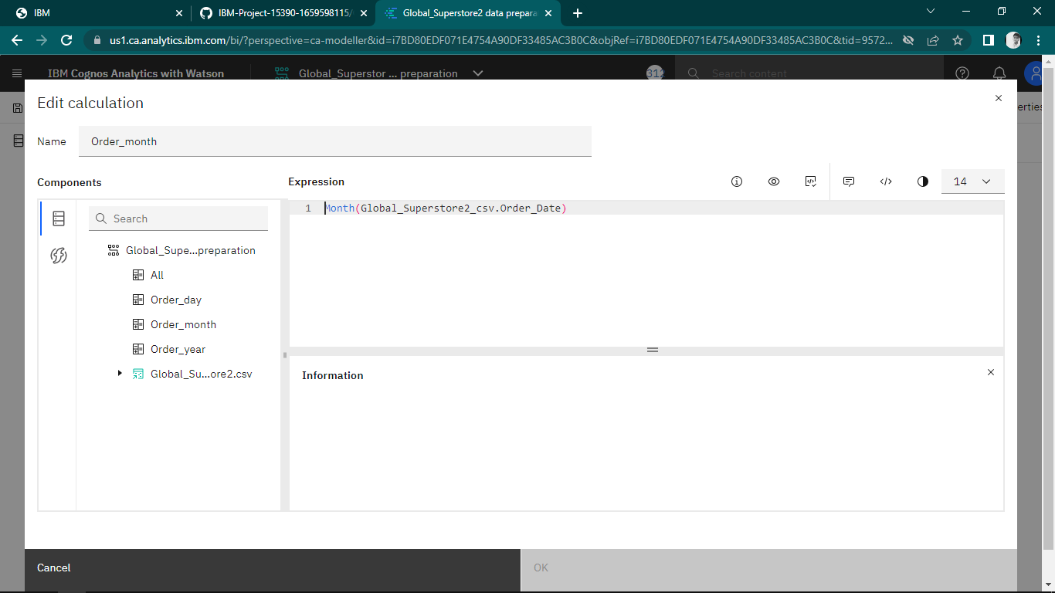

1. **Day calculation**

Creating calculations for extracting day from order date column.

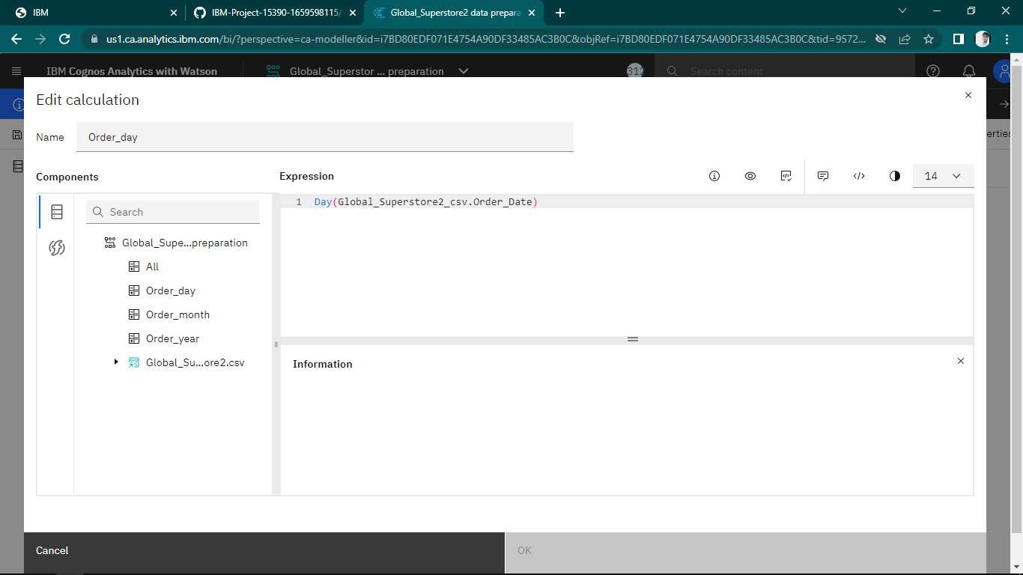

**c. Navigation path:**

Creating navigation path for order date, order year, order month and order day

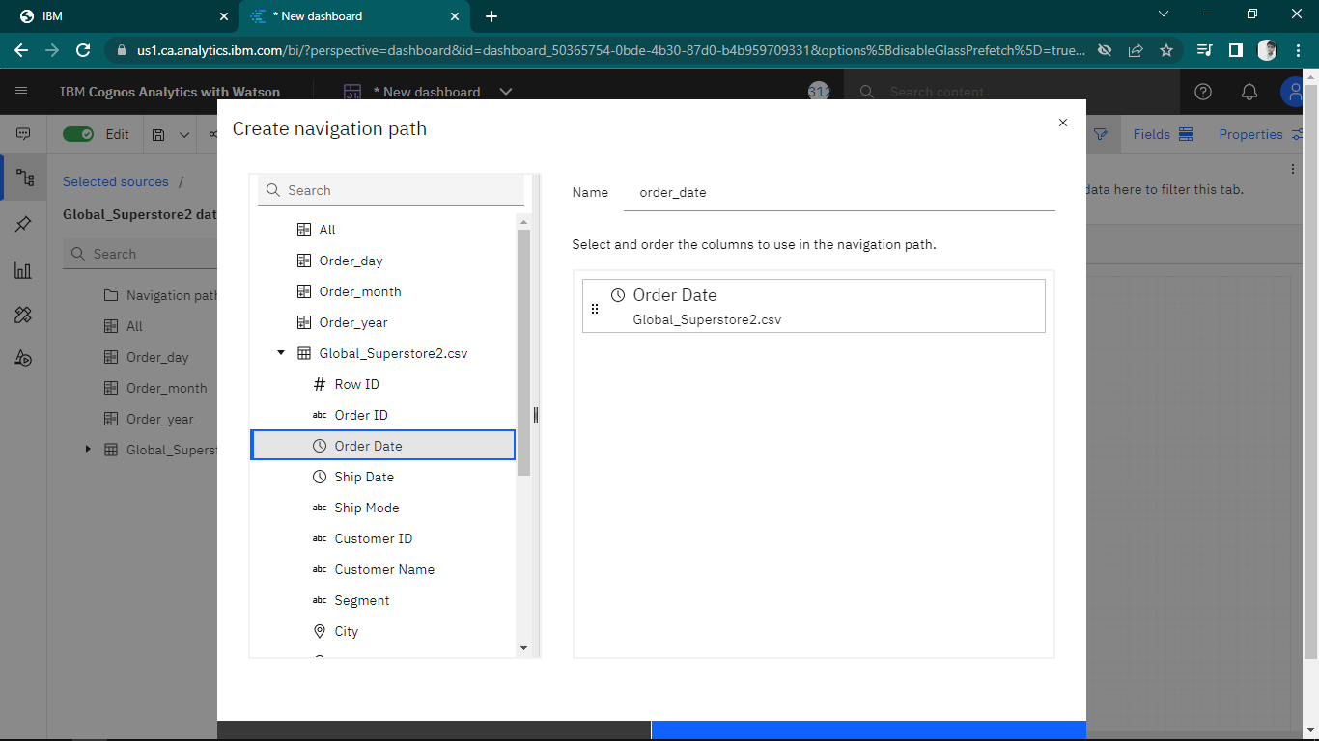

**d. Data formatting:**

Creating navigation path for order date, order year, order month and order day.

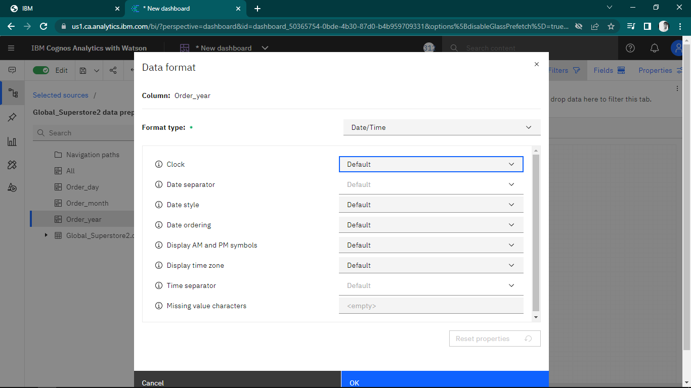

**Creating Dashboard:**

**Segment wise sales, Profit and Quantity:**

The following bar chart shows the distribution of Sales, Profit and Quantity by segments.

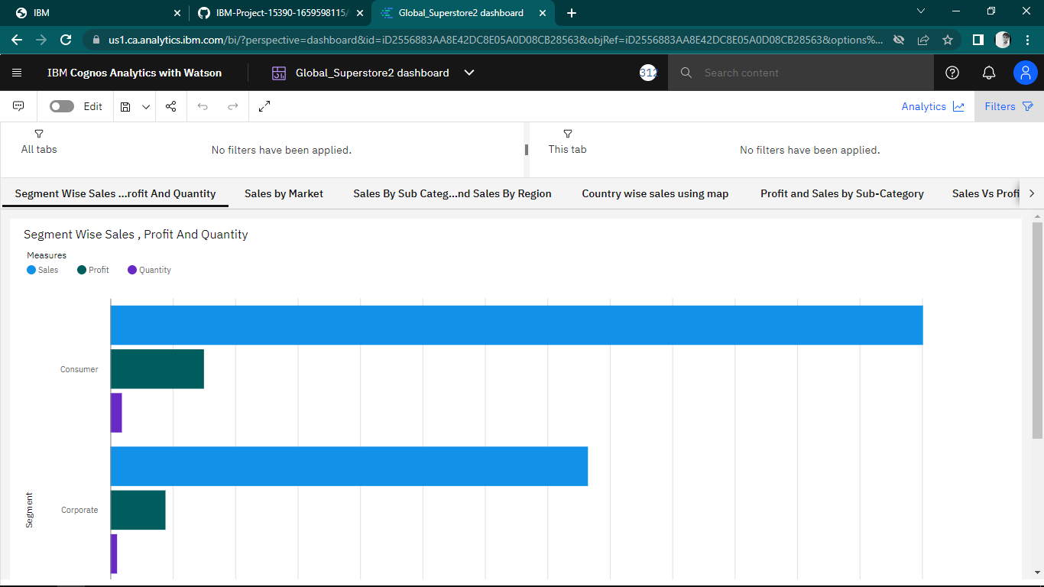

**Sales by Market:**

The below Pie visualization represents the Sales distribution by market.

